CYBERSECURITY AND CYBER THREATS AND ATTACKS
SUMMATIVE ASSESSMENT MEMO

Module Code | 252901001-KM-03
NQF Level | 5
Credits | 12
Curriculum Code | 252901001
Qualification Title | Occupational Certificate: Cybersecurity Analyst
SAQA QUAL ID | 118986

Name
Contact Address
Telephone (H)
Telephone (W)
Facsimile
Cellular
E-mail

Note to the learner
This Learner Guide provides a comprehensive overview of the module. It is designed to improve the skills and knowledge of learners, and thus enabling them to effectively and efficiently complete specific tasks.
Entry Requirements

- NQF 4
Provider Accreditation Requirements for the Knowledge Module

Physical Requirements
- The provider must have lesson plans and structured learning material or provide learners with access to structured learning material that addresses all the topics in all the knowledge modules as well as the applied knowledge in the practical skills.
- QCTO/ MICT SETA requirements

Human Resource Requirements:
- Lecturer/learner ratio of 1:20 (Maximum)
- Qualification of lecturer (SME):
    - NQF 6 in industry recognised qualifications with 1 years’ experience in the IT industry
    - CYBERSECURITY vendor certification
- Assessors and moderators: accredited by the MICT SETA
Legal Requirements
- Legal (product) licences to use the software for learning and training
- OHS compliance certificate
- Ethical clearance (where necessary)
Module Purpose
The main focus of the learning in this knowledge module is to build an understanding of principles of cybersecurity and Ethical Hacking and the types of threats and attacks and the respective risk

Topic elements to be covered include
The learning will enable learners to demonstrate an understanding of:
- KM-03-KT01: Information security Governance and compliance
- KM-03-KT02: Information security
- KM-03-KT03: Foot printing and Reconnaissance
- KM-03-KT04: Scanning Networks
- KM-03-KT05: Enumeration
- KM-03-KT06: Vulnerability Analysis
- KM-03-KT07: System Hacking
- KM-03-KT08: Malware Threats
- KM-03-KT09: Sniffing
- KM-03-KT10: Social Engineering
- KM-03-KT11: Denial-of-Service
- KM-03-KT12: Session Hijacking
- KM-03-KT13: Evading IDS, Firewalls, and Honeypots
- KM-03-KT14: Hacking Web Servers
- KM-03-KT15:SQL Injection
- KM-03-KT16: Hacking Wireless Networks
- KM-03-KT17: Hacking Mobile Platforms
- KM-03-KT18: IoT Hacking
- KM-03-KT19: Cloud Computing
- KM-03-KT20: Cryptography
- KM-03-KT21: Cyber incident response and management

Venue, Date and Time:
Consult your facilitator should there be any changes to the venue, date and/or time.
Refer to your timetable
Assessments

The only way to establish whether you are competent and have accomplished the learning outcomes is through continuous assessments. This assessment process involves interpreting evidence about your ability to perform certain tasks. You will be required to perform certain procedures and tasks during the training programmer and will be assessed on them to certify your competence.

This module includes assessments in the form of self-evaluations/activities and exercises. The exercises, activities and self-assessments will be done in pairs, groups or on your own. These exercises/activities or self-assessments (Learner workbook) must be handed to the facilitator. It will be added to your portfolio of evidence, which will be proof signed by your facilitator that you have successfully performed these tasks.

Listen carefully to the instructions of the facilitator and do the given activities in the time given to you.

Question
1
Define the Concepts of information security
What is Information Security (InfoSec)?
Information security (sometimes referred to as InfoSec) covers the tools and processes that organizations use to protect information. This includes policy settings that prevent unauthorized people from accessing business or personal information. InfoSec is a growing and evolving field that covers a wide range of fields, from network and infrastructure security to testing and auditing.
Information security protects sensitive information from unauthorized activities, including inspection, modification, recording, and any disruption or destruction. The goal is to ensure the safety and privacy of critical data such as customer account details, financial data or intellectual property.
The consequences of security incidents include theft of private information, data tampering, and data deletion. Attacks can disrupt work processes and damage a company’s reputation, and also have a tangible cost.
Organizations must allocate funds for security and ensure that they are ready to detect, respond to, and proactively prevent, attacks such as phishing, malware, viruses, malicious insiders, and ransomware.
Question
2
Outline three principles of information security?
The basic tenets of information security are confidentiality, integrity and availability. Every element of the information security program must be designed to implement one or more of these principles. Together they are called the CIA Triad.
Confidentiality
Confidentiality measures are designed to prevent unauthorized disclosure of information. The purpose of the confidentiality principle is to keep personal information private and to ensure that it is visible and accessible only to those individuals who own it or need it to perform their organizational functions.
Integrity
Consistency includes protection against unauthorized changes (additions, deletions, alterations, etc.) to data. The principle of integrity ensures that data is accurate and reliable and is not modified incorrectly, whether accidentally or maliciously.
Availability
Availability is the protection of a system’s ability to make software systems and data fully available when a user needs it (or at a specified time). The purpose of availability is to make the technology infrastructure, the applications and the data available when they are needed for an organizational process or for an organization’s customers.
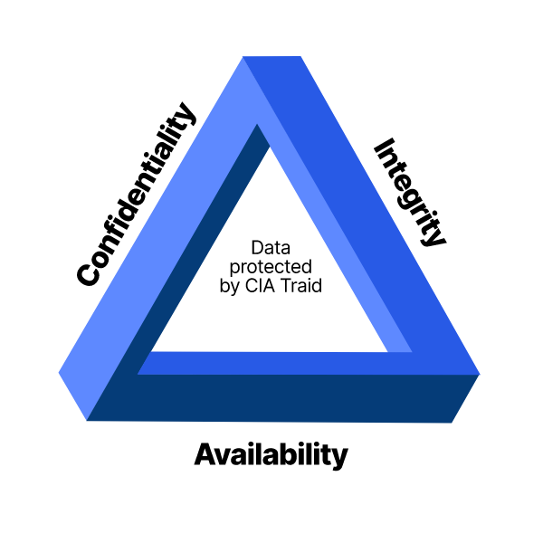
The CIA Triad defines three key principles of data security

Question
3
Describe how risks and mitigation related to foot ringing and reconnaissance are interrogated.
- Creating awareness among the employees and users about the dangers of social engineering.
- Limiting the sensitive information.
- encrypting sensitive information.
- using privacy services on whois lookup database.
- Disable directory listings in the web servers.
- Enforcing security policies.

Question
4
Define Enumeration
Penetration testing or Ethical hacking is a simulation of cyber-attacks to a computer system or application or infrastructure to detect vulnerabilities, if any. Penetration testing provides great insights on the list of vulnerabilities which we can categorize and rank as high, medium and low. We fix these vulnerabilities depending on the business requirement and timelines.
Question
5
Outline various phases of penetration testing
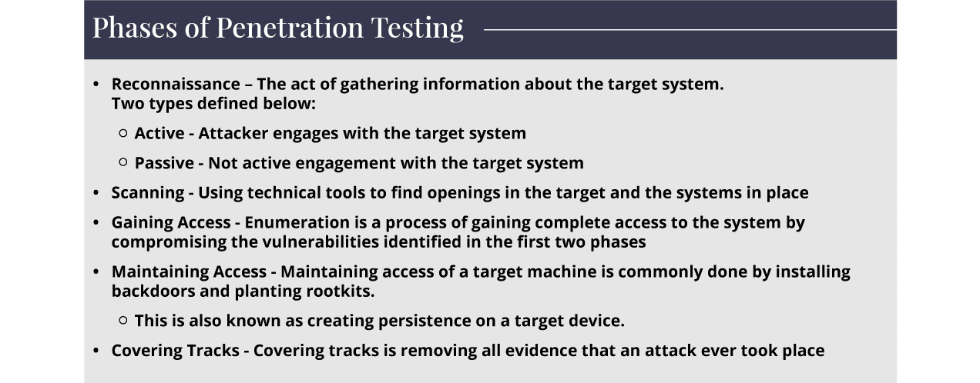
Description of Enumeration
Enumeration is the phase 3 of the Penetration Testing or Ethical Hacking. It is a process of gaining complete access to the system by compromising the vulnerabilities identified in the first two phases. The Scanning stage only helps to identify the vulnerabilities to a certain extent, but Enumeration helps us learn the complete details such as users, groups and even system level details – routing tables. This phase of the Ethical hacking is to gain end-to-end knowledge of what will be tested in the target environment. Tools are deployed to gain complete control over the system.
Significance of Enumeration
Enumeration is the most critical aspect of Ethical hacking. The metrics, outcomes, results are used directly in testing the system in the next steps of penetration testing. Enumeration helps us to decipher the detailed information – Hostnames, IP tables, SNMP and DNS, Application, Banners, Audit configurations and service settings. The significance of Enumeration is that it systematically collects details. This allows pentesters to completely examine the systems. The pentesters collect information about the weak links during the enumeration phase of ethical hacking.
Enumeration helps in finding the attack Vectors and threats.
Enumeration Classification
We can perform enumeration on the following:
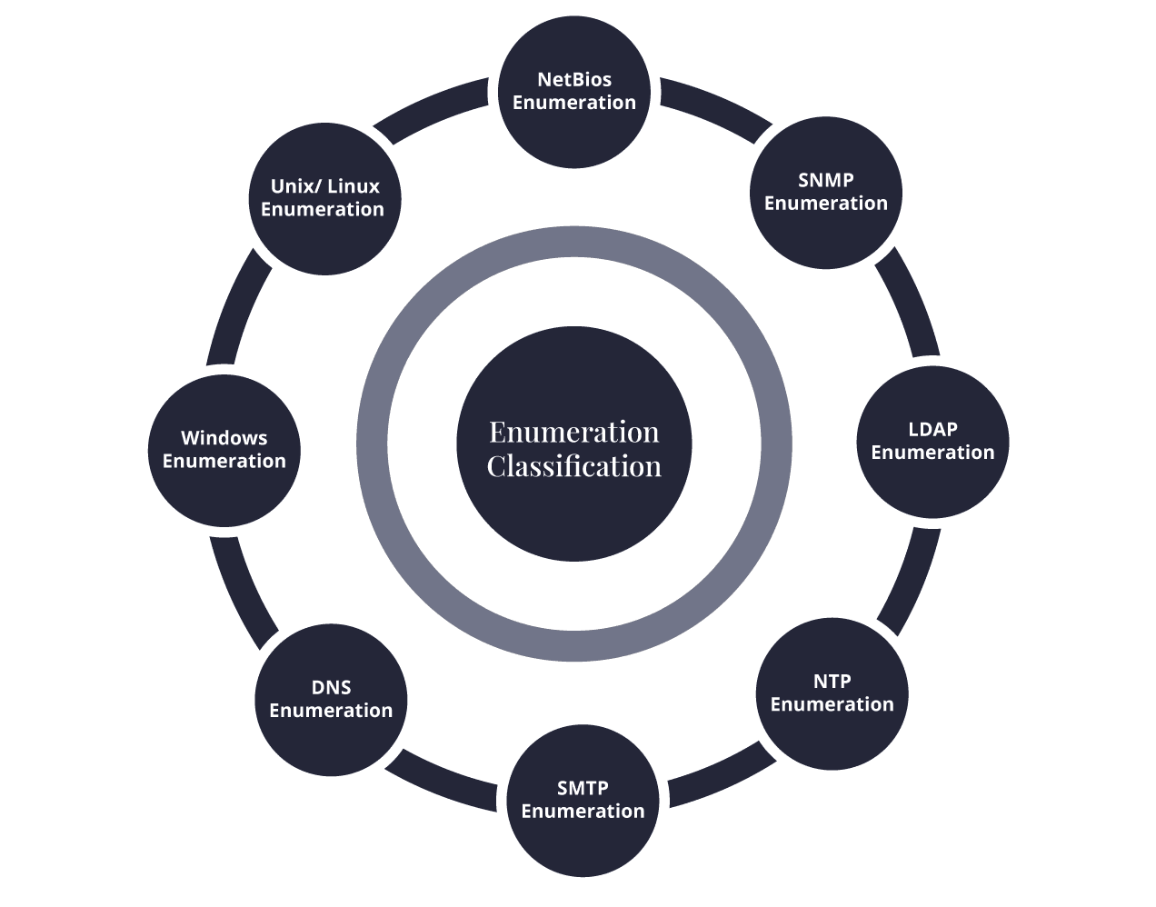

Enumeration and its types – Tool box
Enumeration as a process extracts the user names, machine names, network resources, shares and services from the ecosystem. There is a robust toolbox that helps the enumeration process become scalable. This is a mix of software and hardware systems. There are free and commercial software tools for the enumeration. The hardware tools are mainly the key loggers and special wireless hardware. The pentesters find the right and optimum way to reach the various components of the systems.
Techniques for Enumeration
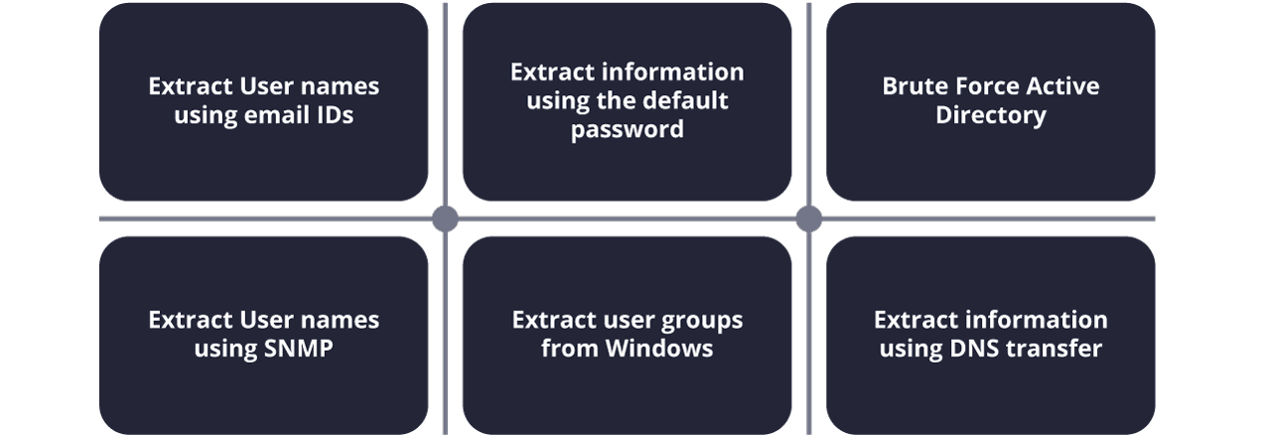

Question
6
Give four types of information enumerated by intruders:
The types of the information enumerated by intruders are the following:
- Network source
- Users and groups
- Routing tables
- Audit settings
- Service configuration settings
- The various machine names
- Applications
- Banners
- SNMP details
- DNS details

Question
7
Explain the purpose of system hacking
Generally, the motive of the hackers behind System Hacking is gaining access to the personal data of an individual or sensitive information belonging to an organization in order to misuse the information and leak it which may cause a negative image of the organization in the minds of people, Privilege Escalation, Executing malicious applications to constantly monitor the system.
How this is carried out?
This type of hacking is generally done by a Hacker who has a lot of information regarding the System security, network, software, and how the system communicates with others in the network, often called Footprinting and Reconnaissance. Then these hackers try numerous ways to carry out the attack but the common ways are:
- By deploying Viruses, Worms, Malware, Trojans
- Using phishing techniques
- Social Engineering
- Identifying and exploiting Vulnerability
Steps:
1. Reconnaissance: The first step in this type of Hacking is collecting information regarding the System’s infrastructure, working, system’s network. This step is very important as after this step the Hacker knows what attack to perform and how to gain access without leaving a trace.
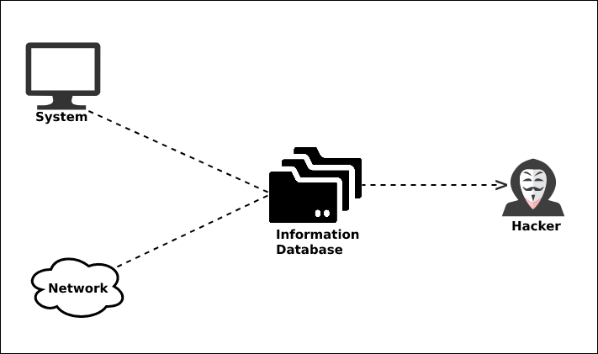

2. Scanning: This step involves scanning the target System, which includes:
- Vulnerability Scanning: Checking vulnerabilities in the targeted system that can be exploited to gain access.
- Mapping of Network: Finding the working of the network, firewalls, routers, and systems connected to it.
- Port Scanning: Scanning the open ports, and services running over the System/Server.
3. Gaining Access: This is the phase in which the hacker breaks into the system and gains unauthorized access to the System/Network and then elevates his privileges to that of Administrator or SuperUser so he can play with the System files that a normal/Guest user is unable to access.
4. Maintaining the Access: After the Hacker enters the System he tries to maintain the connection with it in the background until he accomplishes the goal with which he entered it.

Question
8
What is sniffing software used for?

Legitimate uses for sniffing software
Skilled technicians place sniffers inside a network to tap into its traffic and track what’s being sent. You’ve probably seen at least one movie in which a crafty detective puts a tap on a suspect’s phone line, then listens in as they discuss all sorts of nasty business. Sniffers are essentially the same thing, but for the internet.
Here’s a short list of a people who might make use of a network sniffer:
- Network engineers: By analyzing the type and level of traffic on a network, engineers can use the data to optimize their network’s structure for efficiency and speed.
- System admins: Network sniffers are amazing troubleshooting tools. Sysadmins can dive into bottlenecks or other slowdowns as they’re happening to examine the issue.
- Employers: IT technicians at a corporate office may use sniffers to monitor their employees while at work. Employers can learn about the websites their workers are visiting, how much time they spend there, and whether they’re viewing or downloading anything they shouldn’t be.
- Security professionals: Unusual traffic amounts or types can indicate that everything is not as it seems. Security teams can identify atypical internet usage patterns that may indicate the presence of a hacker or malware. Speaking of which.

.

Question
9
What is passive sniffing?
Hubs are simple networking devices that connect several devices together into a single network. There aren’t any regulatory mechanisms that steer traffic to its intended recipient; rather, all devices receive all the traffic, and then determine whether or not that traffic is relevant.
Because all devices in a hub receive all the network’s traffic, a sniffer can easily — and passively — soak up everything that’s being sent. There’s nothing to actually do other than sit back and sniff. This makes passive sniffing very difficult to detect. Not impossible, but difficult.

Question
10
Explain common categories of tools for DDoS attacks:
Low and Slow Attack Tools
DDoS attack tools under this category use a low volume of data and run sluggishly as they’re made to send small packets of data across several network connections. This keeps ports on a specific server open for a longer time to consume a server’s resources. The process goes on until the server fails to handle any more requests.
Application Layer-7 Attack Tools
To understand this, you must know what the OSI model is. Open Systems Interconnection or OSI models are the seven layers computer systems use to communicate over a network. All major computer and telecommunication companies accepted and synchronized with the OSI model in the 1980s.
So, as the name says, application layer-7 attack tools target the seventh layer of the OSI model where HTTP requests are generated. Bad actors overwhelm servers with traffic that looks like legitimate requests made by users.
Protocol and Transport Layer Attack Tools
This category of DDoS attack tools uses UDP and heavy-volume traffic to overburden a server and render it dysfunctional. The UDP or User Datagram Protocol is used for time-sensitive transmissions like videos and DNS lookups. Its job is to speed up communications without a formal connection before data transmission.

Question
11
List famous DDoS Attack Tools
Below are the nine most famous DDoS attack tools. Their usage depends on what industries the attackers target and their intentions.
LOIC
LOIC or Low Orbit Ion Cannon is a beginner-friendly, free, and famous DDoS attack tool used for sending UDP, TCP, and HTTPS requests to a targeted server. It uses a significant volume of traffic to its advantage by focusing on a computer’s network connection and sending unnecessary packets to shut down a website.
HULK
HULK is short for HTTP Unbearable Load King, a tool designed for research purposes. It’s a choice of many attackers since it overloads the server with legitimate requests that don’t leave a trace or create suspicion.
As the server is driven on HTTP, it bypasses the cache engine and generates obscure traffic.
Tor’s Hammer
Tor’s Hammer is categorized under low and slow tools for DDoS attacks and was initially meant for testing purposes only. It can attempt attacks inside the Tor network that operate in the 7th layer of the OSI model. It works by activating dead connections, thus confusing the web to show results.

Question
12
Define a Honeypot
Honeypot is designed primarily for tracking or attacking attackers during their attempts to break into an organization system. Attackers would try to detect the presence of honeypots on the network by propping services running on the system. These probs would include crafting malicious packets such as HTTPS, SMTPS, etc. For example. Ports that should a running service but deny a three-way handshake might indicate the presence of honeypot.
Attackers can also defeat honeypots by using multi-proxies (TORs) and hiding their conversations using encryption and steganography techniques. However, they are Some techniques used to identify and defeat the honeypots system, as discussed below. (EC-Council, 2020)
·

Question
13
Describe what is SQL injection
SQL injection is one of the biggest challenges for the web application security. Based on the studies by OWASP, SQL injection has the highest rank in the web based vulnerabilities. In case of a successful SQL injection attack, the attacker can have access to the web application database. With the rapid rise of SQL injection based attacks, researchers start to provide different security solutions to protect web application against them. One of the most common solutions is the using of web application firewalls.
Usually these firewalls use signature based technique as the main core for the detection. In this technique the firewall checks each packet against a list of predefined SQL injection attacks known as signatures. The problem with this technique is that, an attacker with a good knowledge of SQL language can change the look of the SQL queries in a way that firewall cannot detect them but still they lead to the same malicious results. In this paper first we described the nature of SQL injection attack, then we analyzed current SQL injection detection evasion techniques and how they can bypass the detection filters, afterward we proposed a combination of solutions which helps to mitigate the risk of SQL injection attack.

Question
14
Give examples of mobile attack vectors
- Malware
  - Virus and Rootkit
  - Application modification
  - OS modification
- Data Exfiltration
  - Data leaves the organization
  - Print screen
  - Copy to USB and backup loss
- Data Tampering
  - Modification by another application
  - Undetected tamper attempts
  - Jail-broken devices
- Data Loss
  - Device loss
  - Unauthorized device access
  - Application vulnerabilities
Question
15
Explain the Consequences of Attack Vectors
Attack vectors is the hacking process as explained and it is successful, following is the impact on your mobile devices.
- Losing your data − If your mobile device has been hacked, or a virus introduced, then all your stored data is lost and taken by the attacker.
- Bad use of your mobile resources − Which means that your network or mobile device can go in overload so you are unable to access your genuine services. In worse scenarios, to be used by the hacker to attach another machine or network.
- Reputation loss − In case your Facebook account or business email account is hacked, the hacker can send fake messages to your friends, business partners and other contacts. This might damage your reputation.
- Identity theft − There can be a case of identity theft such as photo, name, address, credit card, etc. and the same can be used for a crime.
Anatomy of a Mobile Attack
Following is a schematic representation of the anatomy of a mobile attack. It starts with the infection phase which includes attack vectors.
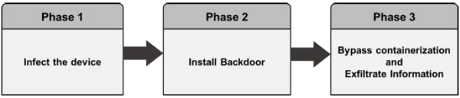
Infecting the device
Infecting the device with mobile spyware is performed differently for Android and iOS devices.
Android − Users are tricked to download an app from the market or from a third-party application generally by using social engineering attack. Remote infection can also be performed through a Man-in-the-Middle (MitM) attack, where an active adversary intercepts the user’s mobile communications to inject the malware.
iOS − iOS infection requires physical access to the mobile. Infecting the device can also be through exploiting a zero-day such as the JailbreakME exploit.
Installing a backdoor
To install a backdoor requires administrator privileges by rooting Android devices and jailbreaking Apple devices. Despite device manufacturers placing rooting/jailbreaking detection mechanisms, mobile spyware easily bypasses them −
Android − Rooting detection mechanisms do not apply to intentional rooting.
iOS − The jailbreaking “community” is vociferous and motivated.
Bypassing encryption mechanisms and exfiltrating information
Spyware sends mobile content such as encrypted emails and messages to the attacker servers in plain text. The spyware does not directly attack the secure container. It grabs the data at the point where the user pulls up data from the secure container in order to read it. At that stage, when the content is decrypted for the user’s usage, the spyware takes controls of the content and sends it on.
How Can a Hacker Profit from a Successfully Compromised Mobile?
In most cases most of us think what can we possibly lose in case our mobile is hacked. The answer is simple - we will lose our privacy. Our device will become a surveillance system for the hacker to observer us. Other activities of profit for the hacker is to take our sensitive data, make payments, carry out illegal activities like DDoS attacks.

Question
16
Explain the concepts and principles of Cyber incident response and management
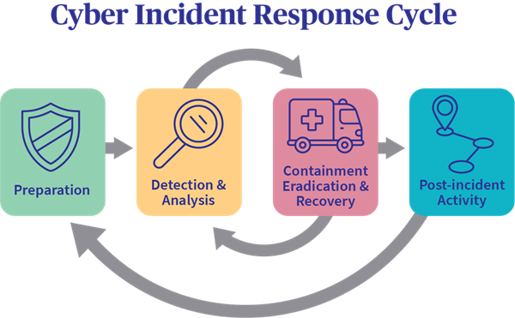
Incident Response
Incident response (IR) is a set of information security policies and procedures that you can use to identify, contain, and eliminate cyberattacks. The goal of incident response is to enable an organization to quickly detect and halt attacks, minimizing damage and preventing future attacks of the same type.
In this page you will get an in-depth understanding of incident response processes, people and tools:
Question
17
Outline the phases of the incident response lifecycle
There are six steps to incident response. These six steps occur in a cycle each time an incident occurs. The steps are:

- Preparation of systems and procedures
- Identification of incidents
- Containment of attackers and incident activity
- Eradication of attackers and re-entry options
- Recovery from incidents, including restoration of systems
- Lessons learned and application of feedback to the next round of preparation

